AI-Based Fake News Detection System Using Machine Learning
Sahil  Department of Computer Science and Engineering  Chitkara University Institute of  Engineering and Technology,  Chitkara University  Rajpura, Punjab, India sahil2211.be22@chitkara.edu.in | Sachin Kumar  Department of Computer Science and Engineering  Chitkara University Institute of  Engineering and Technology,  Chitkara University  Rajpura, Punjab, India sachin2204.be22@chitkara.edu.in

Abstract
There has been considerable misinformation and fake news spread due to the fast-paced rise of digital media platforms. It becomes increasingly difficult and ineffective to manually verify such content in a timely manner. This paper describes the design and implementation of an Artificial Intelligence-based Fake News Detection System employing machine learning and Natural Language Processing (NLP). Data pre-processing is carried out on the textual data through tokenization, elimination of stop words, and stemming and then converted into TF-IDF vectors. Several machine learning algorithms such as Logistic Regression, Random Forest, and Gradient Boosting are employed for building models. Experimental results show that ensemble machine learning models give much better generalization with Gradient Boosting giving the best accuracy of 95%.
Keywords--Fake news detection, machine learning, NLP, TF-IDF, Logistic Regression, Random Forest, Gradient Boosting, misinformation, text classification.

I. INTRODUCTION  The rise of social media and online news has fundamentally altered how information is disseminated and received. In the present day, news stories can reach millions of users instantaneously, with communication speeds reaching previously unimaginable levels. On the other hand, this rapid transmission of information has enabled the unfettered proliferation of fake news. Fake news is a kind of fictitious and distorted data, published and distributed as fact with the aim of misleading the general public, financial gains or society-level confusion.  The problem of fake news is rapidly becoming graver. It has led to widespread misinformation, misguided decisions, political/social/economic instability etc. Fake news can even sway elections, cause great damage during medical emergencies. The amount of content uploaded and produced each day is overwhelming and manually analysing each article is near impossible. Fake news was previously identifiable either by manual cross checking or easily noticeable cues like grammatical mistakes, sensationalism of titles etc. Or by unreliable sources.  In this paper we use the classical ML approaches: Logistic Regression, Random Forest, and Gradient Boosting along with a systematically evaluated comparison using a public Kaggle dataset.  III. OBJECTIVES  1. To create a fake news detection system based on machine learning techniques.  2. To pre-process the text using techniques such as tokenization, stop word removal and stemming.  3. To convert the text into feature vectors using TF-IDF vectorization.  4. To implement three machine learning algorithms such as Logistic Regression, Random Forest and Gradient Boosting.  5. To measure the performance of these models using metrics such as accuracy, precision, recall and F1-score.  6. To select the best performing model.  7. To provide an efficient and scalable solution to identify fake new son large amounts of digital content.  IV. DATASET  A dataset, real and fake news with label was collected from open sources such as kaggle. This dataset comprises of around 44000 news articles belonging to two class, REAL and FAKE. The class is well balanced, from Fig. 3, the percentage of real news is almost 52% while percentage of fake news is 48%. Hence the models trained with this dataset will not be biased toward one specific class  .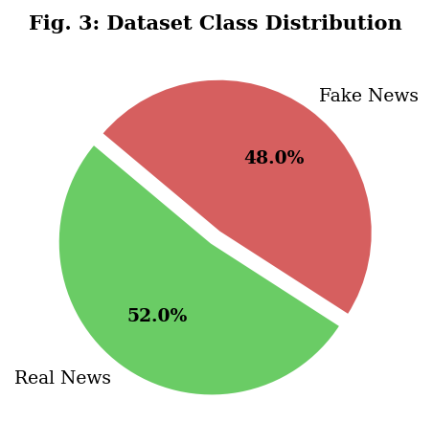  Fig. 1 Dataset Class Distribution  C. ML Classification Models  1. Logistic Regression: This is a baseline linear classifier for the problem of fake or real classification.  2. Random Forest: It's a bagging based ensemble classifier which consists of multiple decision trees.  3. Gradient Boosting: It is a sequential ensemble method which corrects the errors iteratively.  VI. RESULTS AND ANALYSIS  A. Classification Accuracy  The overall accuracy for each model is listed in Table I and a bar chart comparison can be viewed in Fig. 3.  TABLE I. MODEL CLASSIFICATION ACCURACY  Model Accuracy (%)  Logistic Regression 85%  Random Forest 92%  Gradient Boosting 95%  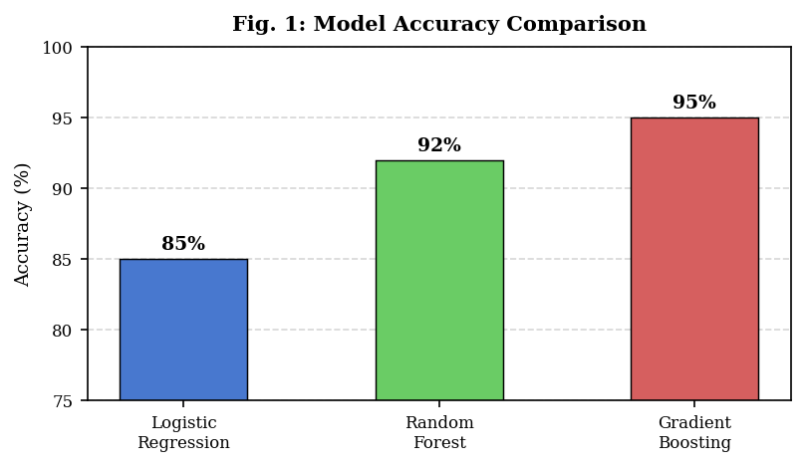  Fig. 3: Model Accuracy Comparison (%)  B. Precision, Recall & F1-Score  The precision, recall, and F1-score values for each model are compared in Table II and Fig. 4.  TABLE II. DETAILED PERFORMANCE METRICS  Model Accuracy Precision Recall  Logistic Regression 85% 83% 84%  Random Forest 92% 91% 90%  Gradient Boosting 95% 94% 95%  model. Henceforth the system could be extended to be with the deep neural networks like LSTM, CNN or transformer-based models.  VIII. CONCLUSION  This paper successfully proves that Machine Learning and NLP tools are used for fake news detection in a digital environment. The developed system makes use of a full pipeline which involves text preprocessing, TF-IDF features extraction and classification by means of ML models. The accuracy obtained reaches 95% when using Gradient Boosting.  This system serves as an automated, scalable method of countering disinformation as compared to traditional human verification methods. Future work would incorporate deep learning models such as LSTM and BERT-based transformers in order to improve the precision of the system further.  REFERENCES  [1] The Fake News Detection Dataset, as found on Kaggle [online]. Available at: https://www.kaggle/  [2] F. Pedregosa et al., "Scikit-learn: Machine Learning in Python," J. Mach. Learn. Res. Vol. 12, pp. 2825-2830, 2011.  [3] S. Pal et al., "Applying Machine Learning to Detect Fake News," Intl. J. Computer Sci., 2019.  [4] A. Nigam et al., "Fake News Detection Using NLP Techniques," IEEE Access, vol. 9, 2021.  [5] UCI Machine Learning Repository [online]. Available at: https://archive.ics.uci.edu/  [6] A. Vaswani et al., "Attention Is All You Need," Proc. NeurIPS, 2017.  [7] J. Devlin et al., "BERT: Pre-training of Deep Bidirectional Transformers," Proc. NAACL, 2019. |  | It has advanced considerably with Artificial Intelligence, with automated content creation and now most of these are structurally correct articles and are not easily distinguishable from real news. This paper looks at developing an AI-based Fake News Detection System utilizing Machine learning. The objective is to use NLP techniques to accurately predict whether news articles are fake or not.  II. BACKGROUND & RELATED WORK  The problem of Fake News detection has already been explored well within the research area of NLP and IR. Early methods involved keyword-matching and human fact verification but were very slow and unscalable. More recent methods use supervised learning with handcrafted features such as word counts, sentiments and TF-IDF scores [2]. Pal et al. [3] applied Logistic Regression on TF-IDF scores and reported about 85% accuracy on common benchmarks, later modified and ensemble-based approaches with Logistic Regression on TF-IDF and additional features boosted the accuracy over 90% [4]. LSTMs and BERT have also been tested but are quite computationally intensive.  V. METHODOLOGY  The suggested system follows the standard machine learning pipeline to detect fake news, as given in the flowchart  (Fig. 2).  A. Data Preprocessing  Standard NLP techniques are used for cleaning the raw text data and normalizing them to have a standard form. The techniques applied are:  - Lowercase: Convert all the text into lowercase format.  - Removing punctuation and special characters: Delete all the special characters and punctuation marks.  - Removing stop words: Stop words are common words like 'the', 'is', 'a', etc., which do not contribute to the meaning.  - Tokenization: Convert the text into a sequence of word tokens.  - Stemming/ Lemmatization: Reduce words into their root form.  B. Feature Extraction (TF-IDF)  TF-IDF or term frequency-inverse document frequency, as illustrated in equation 1.1 and explained in the below section, converts the processed text into a numerical vector by weighing each word by the frequency of words that appear in each document.  TF-IDF(t, d) = TF(t, d) log ( N / DF(t))  where TF(t, d) is the number of times a term t appears in a document d, N is the number of documents, and DF(t) is the number of documents containing term t.  SYSTEM FLOWCHART  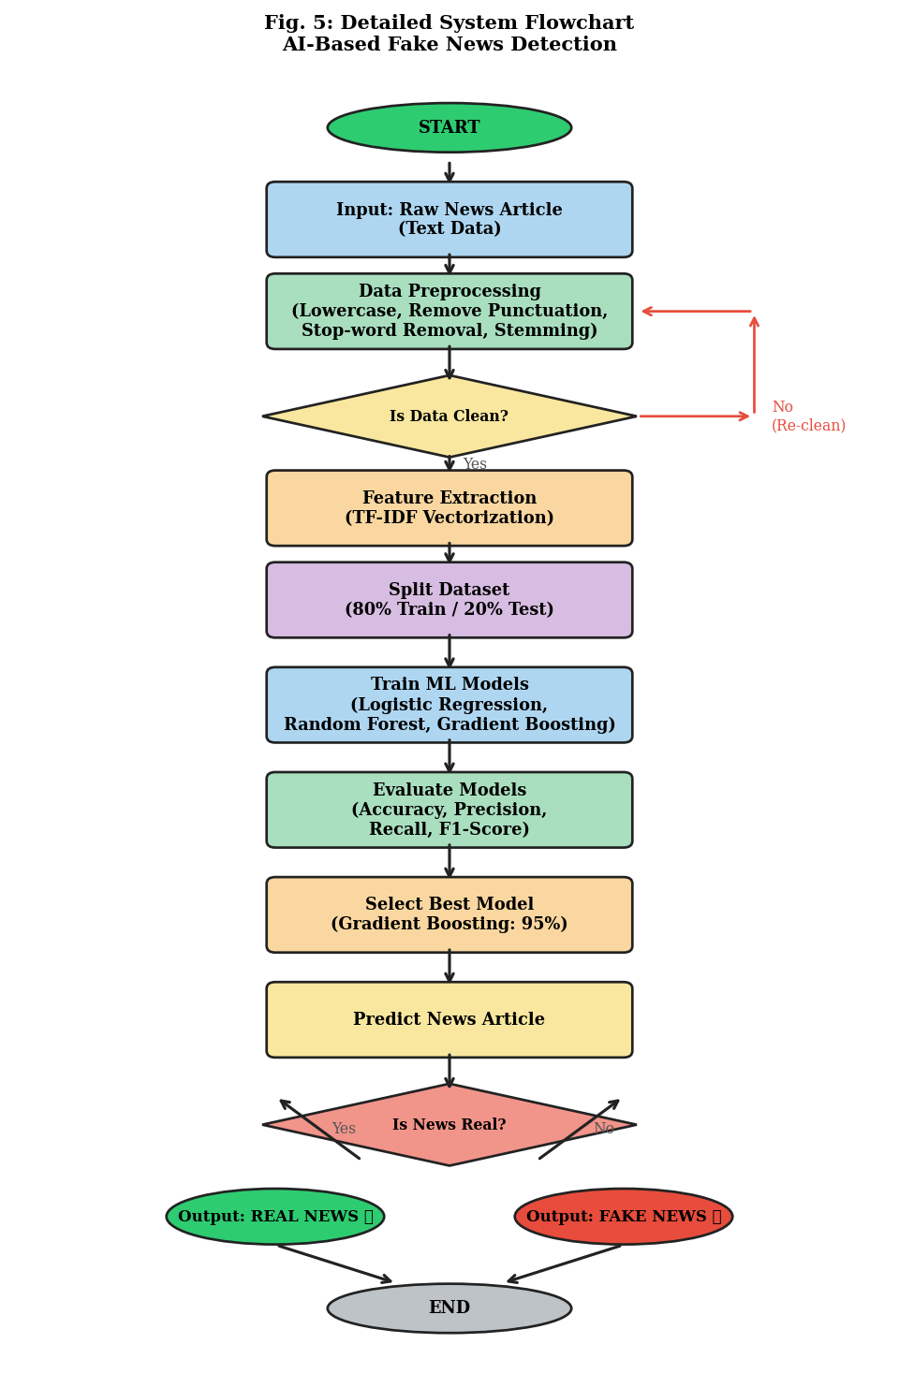  Fig. 2: Detailed System Flowchart for AI-Based Fake News Detection  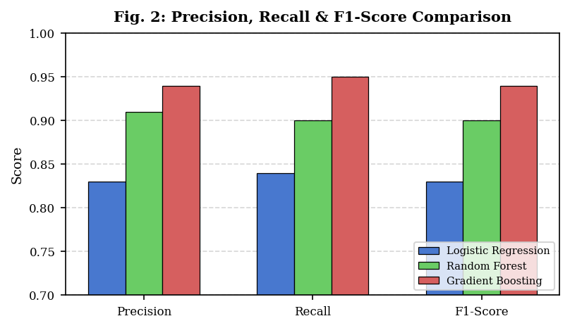  Fig. 4: Precision, Recall & F1-Score Comparison  C. Training vs Validation Accuracy  The learning curve for the Gradient Boosting model can be seen in Fig. 5. This figure shows convergence as training progresses with a small level of overfitting.  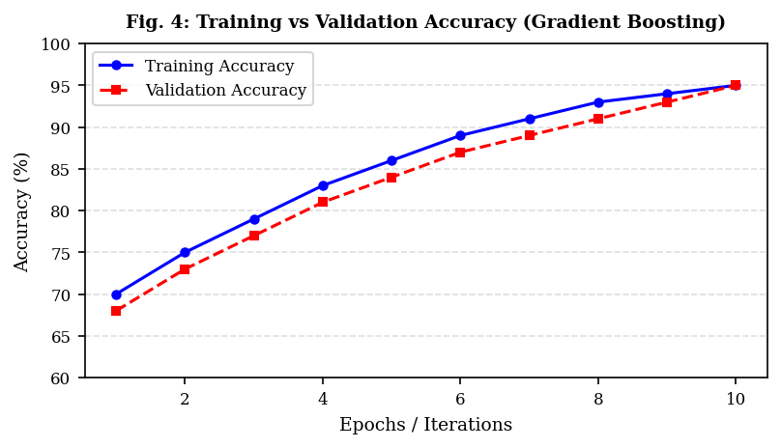  Fig. 5: Training vs Validation Accuracy (Gradient Boosting)  D. Comparison with Traditional Methods  Keyword-based and manual verification systems only have about 65-70% accuracy and can't handle an increased number of detections. These systems require an average human 5 seconds to evaluate the system and will not scale to a large number of detections. The TF-IDF and ML pipeline significantly outperforms these systems and requires no human intervention for the real-time detection.  VII. DISCUSSION  From the experiment results, it is clear that ensemble models are a better choice than linear models in fake news detection. Gradient Boosting performs best with an accuracy of 95%, where it progressively refines misclassifications to learn a complex decision boundary.  TF-IDF feature extraction methodology succeeds in learning discriminant word patterns between true and fake news but more advanced work is expected with context aware embedding approaches, like Word2Vec, Glove, BERT which can take into account semantic nuances of words. One of the main weaknesses of the current system is its dependency on the quantity and balance of training data. Advanced generated fake news by AI will fool current

